1. What are different types of joins and explain them?

Joins are used to combine rows from different tables.

1. Inner Join: Inner join combines the rows from two tables, where the condition is satisfied.

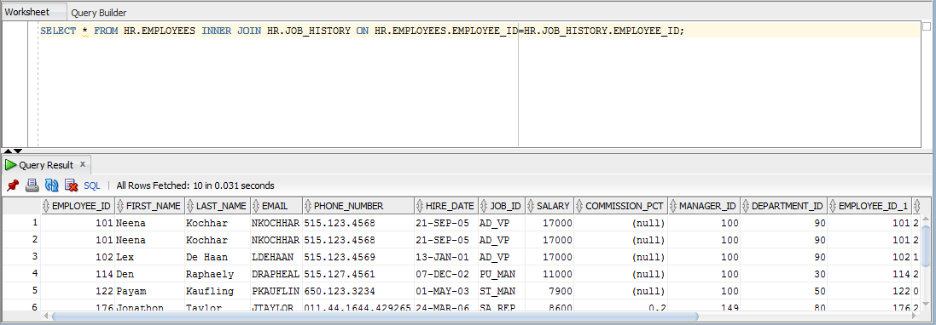

1. Left Join: Left join combines all rows from the table specified on the left, and all the rows which satisfy the condition, from the table specified on right.

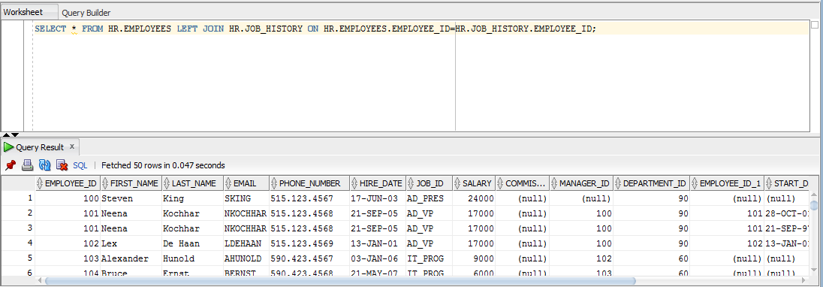

1. Right Join: Right join combines all rows from the table specified on the right, and all the rows which satisfy the condition, from the table specified on left.

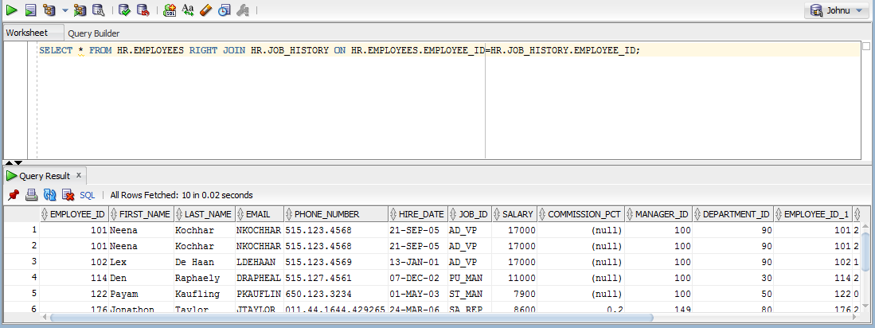

1. Full Join: Full join combines the rows of the tables, when there is at least one match.

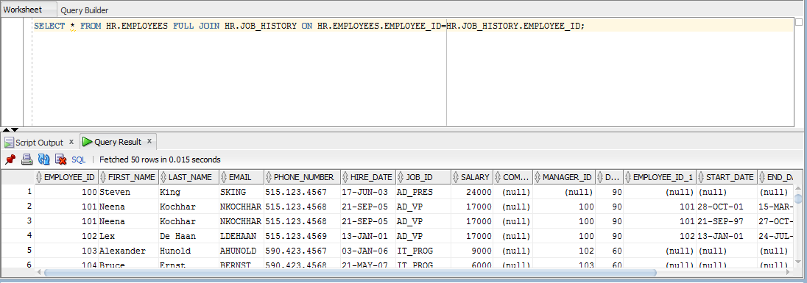

1. What is sub query? Show an example.

A sub query is a query within another query, embedded in the WHERE clause.

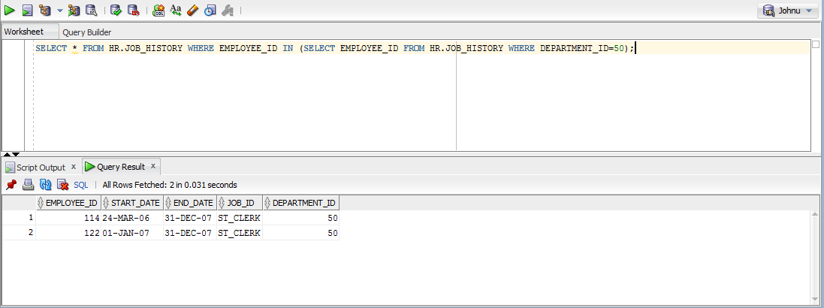

1. What is group by?

Group by is used to perform an operation and get the result set, and then group it and run aggregate queries on the group. Suppose Steve pays state tax and federal tax. If we want to get the sum of all taxes that Steve pays, use Group by query with sum(taxes) function and group the results by name.

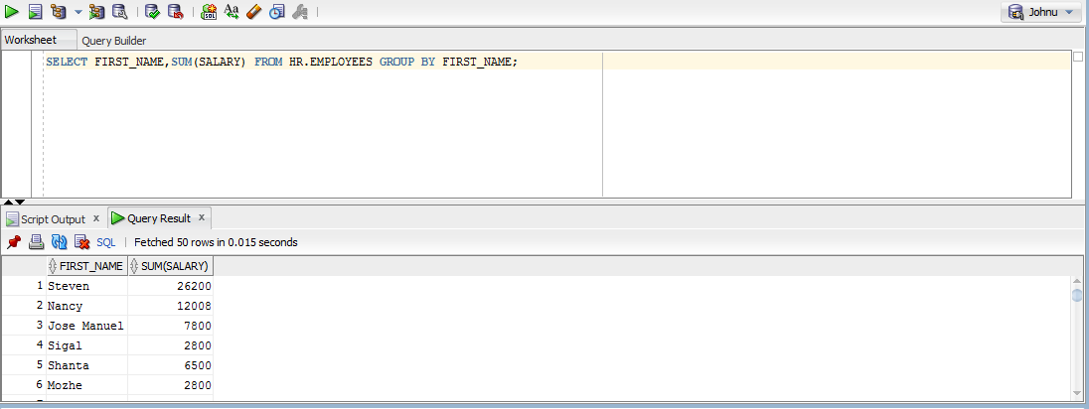

1. What is the difference between order by and group by?

Order By is used for sorting operation. Group by is used to perform aggregate operations on the result set of specific operations.

ORDER BY:

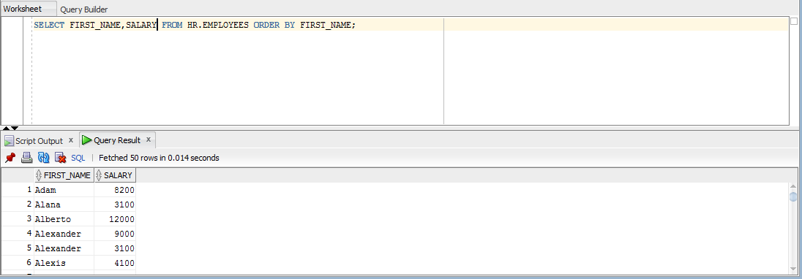

GROUP BY:

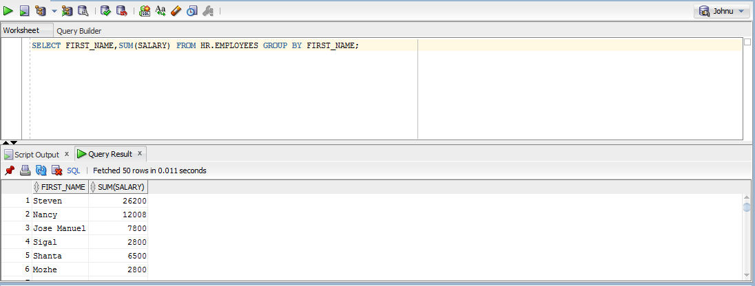

1. What is the difference between left outer join and right outer join?

Left outer join takes all the rows from the table specified on the left, and the matching rows from the table specified on right.

Right outer join is the flip of left outer join. It takes all the rows from the table specified on right, and the matching rows from the table specified on left.

These can be simply said as LEFT JOIN and RIGHT JOIN. They are OUTER by default.

1. What is self join? Explain with an example?

Self join is used to join a table to itself. I couldn’t make it more confusing. 😐

Suppose we have an employee table where we store details of all the employees. Some of them might be programmers, some might be the managers and so on. So, when we want to choose the programmers and their managers and display the results, we have to join the employees table to itself. In this case, we create a temporary copy of the employee table by renaming it and join it to the original table.

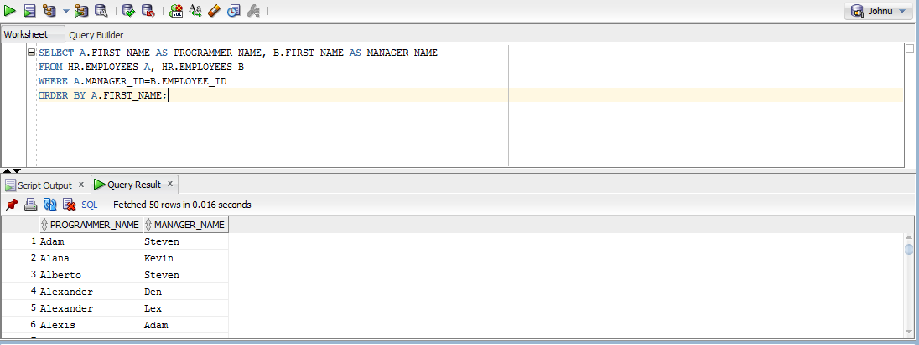

1. What is stored procedure?

Stored procedures are group of SQL queries written and stored in the database. It basically supports re-use of code. Also, faster execution because the compiled version of the code is stored in the cache for frequent use. Better security and lesser network traffic are other advantages.

**Creating the procedure:**

CREATE PROCEDURE DISPLAY_NAME

AS

BEGIN

SELECT FIRST_NAME,LAST_NAME FROM HR.EMPLOYEES;

END;

**To execute the procedure:**

EXECUTE DISPLAY_NAME;

The code looks good for me, didn’t work though. 😐

1. What is stored function?

A stored function is a set of statements that return a single value. It is similar to a function/method in any programming language. The codes which have to be used frequently, like a business formulae can be written in a function. It can take a value, process the statement substituting the value, and return a result depending on the input.

1. What is the difference between stored procedure and function?

A stored procedure may/may not return values. A function must return a value, its mandatory.

Transactions can be used in stored procedures, while not in functions.

Stored procedures can have input or output parameters, while functions can have only input parameters.

A function can be called from a stored procedure, while a stored procedure cannot be called from a function.

Try-Catch blocks can be used with stored procedure, while not in functions.

1. What is view?

A view is a virtual table. A view is created by extracting specific rows and columns from a table, based on specific conditions. It can be used to restrict the user to see a specific part of the table, or join multiple tables so that they look like a single table, aggregate information from a table etc.

View is created using the CREATE VIEW statement.

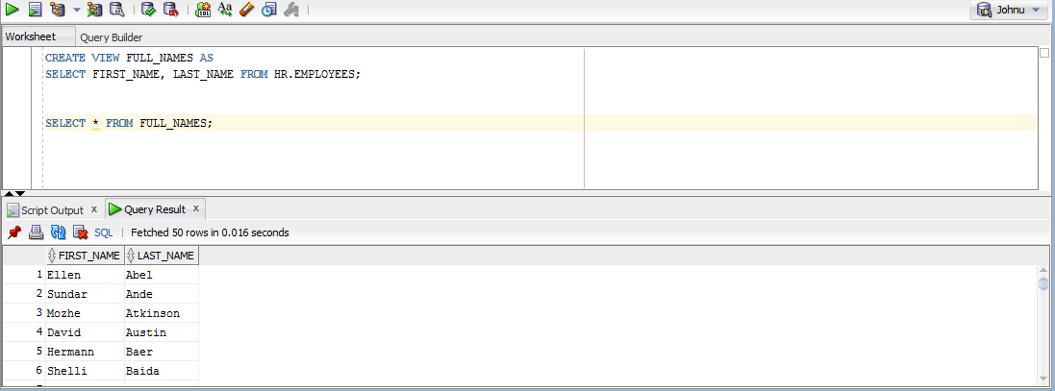

1. What are indexes?

Indexes basically improve the speed of retrieval operations. The indexes are hidden from the users as it does not make any use for them rather than speeding up the whole process. For example, if we want to search for the details of employees with salary more than 10000, without the index, we will have to walk through the entire table searching for matching rows. If we use indexing, the walkthrough can be done through the subset of the table, with the indexes of matching records. It is just like having to go through an entire book to find something, when it does not have an index, while the process is much simplified when the book have an index page. Indexes are created for specific columns in a table.

1. What are different types of constraints? Explain them.
2. NOT NULL – This constraint prevent the column from accepting null values.
3. UNIQUE – A column with unique constraint can only have unique values. That is, duplicates are not allowed.
4. Primary Key – A primary key column must be both unique and not null. The primary key uniquely identifies each row in a table.
5. Foreign key – A foreign key in one table will be the primary key in another table. A foreign key can accept null and duplicate values, differing from the primary key.
6. CHECK – It is used to ensure that the values entered in a column meet specific conditions.
7. DEFAULT – This constraint specifies the default value of a column.